

Student Assessment Submission and Declaration
When submitting evidence for assessment, each student must sign a declaration confirming that the work is their own.
Student name: |  | Assessor name:
Issue date: | Submission date: |  | Submitted on
Programme: HND in Marketing
Unit 34: Digital Marketing
Assignment title:
Digital marketing campaign
Plagiarism
Plagiarism is a particular form of cheating. Plagiarism must be avoided at all costs and students who break the rules, however innocently, may be penalised. It is your responsibility to ensure that you understand correct referencing practices. As a university-level student, you are expected to use appropriate references throughout and keep carefully detailed notes of all your sources of materials for material you have used in your work, including any material downloaded from the Internet. Please consult the relevant unit lecturer or your course tutor if you need any further advice.
Student Declaration
Student declaration
I certify that the assignment submission is entirely my own work and I fully understand the consequences of plagiarism. I declare that the work submitted for assessment has been carried out without assistance other than that which is acceptable according to the rules of the specification. I certify I have clearly referenced any sources and any artificial intelligence (AI) tools used in the work. I understand that making a false declaration is a form of malpractice.

Student signature: Date:

Final Comprehensive Assignment Outline: Social Media Campaign for a Jewellery Retailer

Introduction
The report is about a jewellery retailer in the United Kingdom, which is competitive in the market and which deals with a variety of good jewellery of high quality such as necklaces, rings, bracelets, and earrings among other jewellery. The brand is marketed as a low-price, but luxurious product that meets the fashion trends of those who want to enjoy the luxury and quality that high-end products offer without the high price tag. The jewellery retailer has established its presence in UK with stores in major cities across the UK including London, Cardiff, and Edinburgh. Nevertheless, the company is looking to broaden its marketing targets and raise brand awareness, especially by use of digital marketing and social media avenues. The central aim of the report is to plan an extensive social media campaign that will produce improvements in digital presence of the retailer, inspiration of consumer involvement, and rise in sales. Since the trend has moved to online shopping and an increase in the significance of social media in decision-making when buying specific products, the report will be based on using Instagram, Facebook, and Tik Tok to market the brand and interact with the target audience. The campaign will be structured to meet the specific needs and expectations of the retailer clientele, which eventually attempts to increase brand recognition and customer loyalty, and spur conversions by using well-targeted material and advertising.

Examine the key concepts and features of social media for different business activities

Conceptualisation of Social Media and Platform types
Social media is a collection of websites and tools enabling people and companies to create, share and communicate with information. Such online platforms allow the user to interact, socialize and give opinions on real time basis. Social media is one of the key technologies in the contemporary business environment that helps to connect the brand and the audience. The examples of social media platforms are Instagram, which is a visually oriented media where users are able to share photos and videos, and Facebook, which provides a wide variety of interaction tools, such as text posts, sharing photos, and placing messaging services (Smith, 2022).

Key Concepts of Social Media
Social media use in business activities has three key concepts that support them and are sharing, networking, and community.
Sharing: Sharing is one of the principles of social media. It helps businesses to share promotional messages, information, and updates with a large audience. Social media provides a strong avenue of viral marketing and brand exposure, through sharing, users are able to enhance messages in their networks and magnify. It applies particularly to the businesses that seek to use user-generated content and conduct the marketing of the word of mouth (Johnson, 2021).
Networking: This is done through the use of social media networking that involves businesses, peers and influencers. Relationships with others and brand loyalty can be developed only through networking. As an illustration, LinkedIn enables companies to network and express thought leadership, whereas Instagram provides the connection with a potential customer in the form of influencer partnerships (Jones and Patel, 2021).
Community: It is important that businesses need to create a community where they have a regular customer base. Social media gives the companies an opportunity to interact with the consumer and develop a sense of belonging to a brand. The communities would be cultivated by regular interaction, as in giving feedback on comments, holding interactive campaigns, and inviting people to participate. Community-based websites, such as facebook and Reddit, have emerged as the centers of brand communities with individuals sharing their experiences and feedback (Thompson, 2023).

Key Features of Social Media
Social media websites possess several features that make users more engaged and interactive to the content (i.e. profiles, news feeds, likes/shares).
Profiles: In the social media, businesses and consumers can create profiles that can be used to identify them on this site. To businesses, profiles play a vital role in providing their brand image between the logo, description, and contacts. Profiles represent the presence of a brand online where all the interactions, such as sharing the content, customer support, community, and others, occur (Rosenbaum and Berg, 2022).
News Feeds: News feeds are dynamic and real-time list of posts that are interacted with by the user. The feeds are vital in ensuring that businesses post content that is pertinent to the followers. Feeds algorithmic curating will guarantee prioritizing the most captivating content as one of the ways to make businesses attract the attention of their audience. Any social media campaign must grasp the news feed algorithm and how to optimize content in the social media feeds (Lee et al., 2021).
Likes/Shares: The share/like option is an additional important feature utilized in the promotion of engagement. The likes are an easy recognition of the users, whereas the shares enable users to share the content with their network and get a large audience, the spread of which is geometrical. This aspect is especially helpful in the case of businesses that want to gain organic popularity and impact with the help of social confirmation (Nguyen and Tran, 2023).

The Social Media Environment: Influence of the Emerging Technologies
The social media situation is constantly changing, with the new technologies of Artificial Intelligence (AI), 5G, and Augmented Reality/ Virtual Reality (AR/VR) fast shaping the context.

Artificial Intelligence (AI): AI is augmented in social media in order to transform user experience and company performance. As an example, AI algorithms are employed to personalize the content, target ads with high accuracy, and filter the content created by users. AI can be used by businesses to automatize human customer support with the help of chatbots, understand human behavior, and make personal recommendations. The AI enables companies to be more responsive to the needs of customers and enhance brand interactions (Meyer and Allen, 2021).
5G: The introduction of the 5G technology has transformed social media through the process of adopting faster data transmission coupled with more precise connections. Using 5G, people can receive content in a much faster way, which results in more engagement and viewing of video and other data-intensive content, including videos and live streams. This makes possible business to provide more possibilities of offering more media experiences, including high-quality live streaming, interactive experience and smooth e-commerce experiences (Parker and Chen, 2022).
AR/VR: AR and VR technologies become more popular on the social media to provide the visual experience. On the side of businesses, AR gives the customer the opportunity to see products in their surroundings before they make a purchase, which can be done on platforms such as Instagram and Snapchat. VR, in turn, presents a chance to reach a niche of business creation of virtual showrooms or experiences that would be more interactive and memorable to the users (Kumar and Das, 2021).

The use of social media as an influencer of brand, culture, and values in corporations
The social media is very important in influencing and projecting the brand, culture and values of a company.
Brand Building: Companies apply social media to develop and share their brand name as a leader in their market or even specialists in a niche. By using regular messages, visuals, and interaction with the audience, companies build an identifiable and recognizable brand. Such platforms as Instagram and Twitter are especially efficient in terms of portraying brand personality in visuals and tone of voice (Williams and Thomas, 2021).
Company Culture: This is because social media provides businesses to showcase their internal culture to external audiences. Businesses make the brand more human and establish better relations with customers by sharing behind-the-scenes content, stories with employees and the company values. Social networks are extremely popular in terms of presenting the culture of companies, presenting the success of employees, or entering the sphere of thought leadership (Harris and White, 2022).
Positioning: Social media allows businesses to strategize themselves in the market place. Introducing influencers, targeted advertising, and customer feedback, a company is able to mold the opinions of the masses, impacting their buying choices. The strength of social media in positioning is especially noticeable in such a field as fashion a brand invites an influencer to sell a new collection or exclusive merchandise (Carter and Lee, 2021).

Discuss the business activities that can be influenced by social media
The social media has transformed how businesses carry out their operations including customer service, advertising, brand building and communication. The impact of the social media on business operations is far reaching and has become an imperative component of a marketing strategy, especially to businesses that are intending to expand their market base. In the case of a jewelry manufacturer and retailer, such as the one involved in the vocational scenario, social media will be critical in the interaction with the customers, marketing the products, as well as creating a stronger brand identity.

Most Common applications of Social Media in Business

Consumer Interaction (Customer Service)
The social media gives businesses a platform where they can interact with the consumers and provision customer service instantly. Instagram, Twitter, and Facebook provide the company with opportunities to respond to customer inquiries swiftly, address complaints, and find solutions to the problems. Customer satisfaction and loyalty would be enhanced greatly by this instant communication. In the case of a jewelry retailer, answering questions related to the details of products, their availability, or delivery times will enable customers to feel better about the process and establish a positive brand interaction (Chaffey, 2021). Such degree of interaction is able to assist companies in earning customer confidence and enhancing brand loyalty.

Advertising (External/Internal) and Communication
Social media is a good mode of communication to businesses, both in and out-of-the company. On the outside, social media can be employed by businesses to communicate with customers, suppliers, and other partners. This may comprise product refresh, promotions as well as market trend responses. On the inside, the announcement of the company and recognition of employees, as well as team-building activities, can be done via such social media as LinkedIn (Smith, 2022). Social media advertising that can be conducted on websites such as Facebook and Instagram allows campaigning to be accurately targeted in accordance with demographic and behavioral information, which allows the business to find the correct customer base and target more effectively.

The Effect of the Social Media on Business Operations

Driving Sales
The role of social media in stimulating sales is extremely important as it helps to create specific advertising campaigns and promote products with the help of influencer collaborations. In the case of the jewelry brand, social media can create a platform where the organization can promote novel collections, deals to a considerable number of users, and direct users directly to the business webpage or e-commerce platform (Williams and Thomas, 2021). Secondly, a customer can use apps such as the shoppable posts on Instagram, which can simplify the buying experience by allowing buyers to use the application to buy their desired product.

Delivering Consumer Intelligence
Social media can provide companies with the most valuable information and data about consumer behavior, preference, and trends. The responses through likes, comments, and shares among customers among other types can help the business gain better understanding about the needs of their customers and improve on their products or services. It is especially effective when it comes to a jewelry enterprise because the feedback that consumers provide about novel designs or style can be used to have the brand shape their collections accordingly to address the needs of consumers (Johnson, 2021). Additionally, the social media analytics tools also offer the business valuable demographic information so that the marketing plans can be modified and targeted accordingly to the appropriate consumer segments.

Enabling B2C/B2B Communication
The social media plays a key role in Business-to-Consumer (B2C) and Business-to-Business (B2B) communications. In the case of B2C communication, the social media avenue offers a one-on-one channel of communication with customers, promotional, customer service, and relationship building. B2B communication, in its turn, is often associated with networking, partnerships, and collaboration within the industry that may be helped by such a platform as LinkedIn (Meyer and Allen, 2021). This also facilitates real time communication that helps in operational as well as strategic goals.

Expanding Market Reach
Among the most important impacts of the social media on the business activities is the fact that businesses are able to increase their market coverage through social media. The social media platforms offer a chance to communicate to a large audience across the world at low investment costs, most notably when one uses the paid social ads. Desire of expanding the jewelry trade beyond London, Cardiff and Edinburgh, a jeweler may employ intensive campaigns as a way of accessing the potential customers in the other areas and even further. Facebook, Instagram, and Tik Tok platforms provide the possibility to divide the market according to its location, behavior, etc., which means that the business can provide specific content and promotions to the target demographics, increasing its reach and visibility (Parker and Chen, 2022).

Building Brand Association
The use of social media is an effective means of creating brand association and positioning an identity of the brand. By publicly posting content that embodies the values, culture, and mission of the brand, companies can be able to establish a stronger bond with the target audience. As an illustration, an example could be that a jewelry company takes Instagram to demonstrate the craftsmanship that goes into the production of the products, customer reviews, and how the brand contributes to sustainability or fair working conditions (Thompson, 2023). Interacting with the followers at true and meaningful levels, builds a community around the brand to form long term relationships with the customers.

The Roles of Team Members of the Social Media

Social Media Manager
The tasks that a Social Media Manager carries out entail managing the social media of the company, its content, its posts, monitoring its engagement, and the analysis of the performance measures. They make sure that the social media campaigns should be in line with the overall marketing goals of the company and that the material created should be relevant to the target market. In the case of the jewelry retailer, the Social Media Manager would design campaigns which could focus on new collections, promotions and customer stories making them engaged and brand loyal (Smith, 2022).

Community Manager
Community Manager works on developing and maintaining customer relations with the customers and followers on social media. The social media they use is monitored, commented upon and also interacts with customers in a manner that gives the customer a feeling of owning the community. The Community Manager in the jewelry retailer would address the questions customers have, invite user-generated content (e.g., customer photos in the jewelry of the brand), and make the brand environment positive and supportive (Jones and Patel, 2021).

Content Creator
What they do is through Content Creators who generate the visual and written content to be shared with the social media. They make attractive posts, photos, videos, and graphics that portray the identity of the brand and get the attention of the potential customers. In the case of the jewelry brand, a Content Creator can create quality pictures of jewelry items, behind-the-scenes films of the production process, and influencer partnerships that can be attractive to the target demographics (Nguyen & Tran, 2023).

Discussing the uses of social media and their impact on the market and audience
Social media is an essential instrument to organizations applying different communication goals, such as reaching target audiences, brand perception and improving customer relationships. In the vocational case of the jewelry retailer, the use of social media such as Facebook, Instagram, and LinkedIn can support the attainment of such objectives as reaching the older audience and brand awareness. The current section delves into these communication purposes, advantages and disadvantages of various social media platforms, the strategy of establishing loyal community, and the place of blogs, podcasts and videos in communication.

Communication Objectives

Outreach to Older Audiences
The social media platforms are mostly used differently by the older audience, and companies must adjust their approaches. Social media platforms such as Facebook and LinkedIn can be used to reach consumers who are aged 35 years and above since these social media platforms have high popularity among the older generations (Pew Research Center, 2021). In the case of the jewelry retailer, Facebook will make it possible to target certain age groups and demographics, and the platform will become one of the most effective ways to engage older, potentially well-off consumers who might take a liking to quality jewelry. In order to attract this group of consumers, the content to focus on should be decentralized to product durability, luxurious and customer testimonials, which are better positioned to appeal to the older consumers.

Brand Awareness
Brands awareness especially to a jewelry retailer is very important. As a visual-based platform, Instagram is a great way to advertise new collections, one-time deals, and influencer partnerships. The design and craftsmanship of the jewelry can be revealed through the use of high-quality imagery and content. Real-time updates can be achieved via Instagram Stories and Reels, creating an effect of a sense of urgency and excitement towards the brand. There are also shoppable functions in Instagram, which people are able to make purchases right away, which offers an immediate sale and increased brand exposure (Smith, 2022). Younger and trend-following customers can also be reached by tik-talk, but older audiences will be less served, which means it cannot be used to distribute wider brand awareness.

Scouting the Various Social Media outlets

Facebook
Facebook will be vital in recruitments and customer service with targeting older audiences. The advertising platforms enable the businesses to target the desired groups by use of targeted campaigns. But its algorithm might limit the organic exposure, and therefore, businesses might be required to invest in paid promotion to have more exposure. Facebook groups, reviews, and interactive posts can be used to build a community, which also implies trust, in the case of a jewelry retailer.

LinkedIn
The LinkedIn is mostly beneficial in B2B, so the activity may be applicable when networking with suppliers and other people in the industry arena. In the case of a jewelry retailer, LinkedIn may also be handy, as an opportunity to share thought leadership materials, like posts about sustainable practices, or industry trends, which will put the brand into the market in the role of an expert. Nonetheless, the LinkedIn platform is not as effective as his or her direct consumer interaction with other platforms such as Instagram or Facebook.

Instagram
Instagram is a good place to display the jewelry because it is visual in nature. It provides a number of tools to boost interest, which can be posts, Stories, IGTV, and influencer collaboration. Instagram enables the businesses to have a direct connection between products and the shopping option within the platform, which benefits the purchases process. Nevertheless, it is imperative to produce good and dependable content in order to keep the visibility and interest alive (Williams and Thomas, 2021).

Twitter
Twitter can be used during real-time communication and customer service, which allows the brands to have discussions and address the concerns of customers. It is however difficult to provide in-depth product information due to the character limit and speed of content and Twitter does not necessarily have as much reach as visual media platforms such as Instagram.

Snapchat
Snapchat is mainly popular among younger users and may be efficient in making interactive and entertaining experiences using filters and augmented reality (AR). In the case of a jewellery retailer, the AR filters of Snapchat can enable people to virtually put on a product. Nevertheless, the number of users reached by Snapchat is also lower than such networks as Instagram, and it might not target older audiences.

Onlining Community Growing, maintaining, and cultivating a Loyal Community

Personalized Engagement
Personal response to the comments, messages, and reviews left by the customers is also important towards developing trust. By responding to the customer experiences and feedback directly, which could be achieved by considering it, the brand will be able to enhance its rapport with the audience (Thompson, 2023).

User-Generated Content (UGC)
Customers can be offered to share their personal experience with the brand by writing reviews, testimonials, and publishing photos to gain credibility and attract new followers. The presence of UGC on the social media will demonstrate that the brand appreciates its customers and complements that feeling of community (Nguyen and Tran, 2023).

Consistent Content
Individuals can keep the audience interested by posting frequently and making sure that the content resonates with their interests. In the case of a jewelry retailer, it is possible to show not just products but also background content, client testimonials, and values (like sustainability), which make the brand more human and create closer relationships with the audience.

Use of Blogs, Podcasts and Videos

Blogs
Blogs have the potential of offering quality content on the jewelry industry, trends and care of jewelry in much detail. Businesses can attract traffic to the site by posting information on the social media, which will enhance rankings in search engines and the strength of the brand.

Podcasts
Businesses can use podcasts to interact with the audience at a deeper level. A jeweler can provide talks on the inspiration of design or industry leaders, or conduct interviews. This format contributes to establishing a bond with a niche audience and gives a multidimensionality to the brand communication.

Videos
The videos are among the most captivating forms of contents on social media. In the case of the jewelry retailer, the brand authenticity can be developed through product demonstrations, back-of-the-scene viewing where customers talk to the camera, and about design processes. The video material may be distributed on such platforms as Instagram, Facebook, and YouTube, which enhances exposure and interaction.

Debating the impact of different social media platforms
Social media software is learning to become the essential media that businesses rely on to create brand awareness and attract consumers to the root. In the case of a jewelry retailer such as in the vocational context, the selection of the appropriate platforms is critical to reach the target customers and interact with them. This discussion is based on the effect of various social media platforms Facebook, Instagram, LinkedIn, and Twitter on brand attainment and consumer interaction. The analysis displays the advantages and disadvantages of both platforms and provides information about the potential of each platform in the context of the aims of the jewelry retailer.

Comparative Table: Impact of Social Media Platforms on Brand Awareness and Consumer Engagement
Platform | Impact on Brand Awareness | Impact on Consumer Engagement
Facebook | - Broad reach across all demographics, particularly effective for older consumers. | - Excellent for customer service and community engagement.
 | - Advanced targeting options for advertising based on age, location, and interests. | - Interaction via comments, likes, and direct messages.
 | - Great for promoting content, events, and product launches. | - Engagement often requires paid ads due to algorithm changes.
Instagram | - Highly visual, ideal for showcasing products and building brand identity. | - Strong engagement through Stories, likes, comments, and user-generated content.
 | - Features like Stories and Reels drive quick visibility for new products. | - High potential for influencer partnerships and collaborations.
 | - Strong appeal to younger audiences, but older demographics are also engaged. | - Engagement is driven by consistent, high-quality content.
LinkedIn | - Useful for B2B brand awareness, particularly for building professional credibility. | - Engagement is typically more focused on thought leadership and industry insights.
 | - Best suited for establishing a brand’s authority in its sector. | - Limited B2C engagement, but useful for networking and partnerships.
Twitter | - Great for real-time brand visibility and staying top-of-mind. | - High engagement potential for short, witty content and customer interaction.
 | - Effective for spreading brand awareness through hashtags and trending topics. | - Limited to quick exchanges; not ideal for in-depth engagement.

Impact of Social Media Platforms on Brand Awareness

Facebook
Facebook is still among the biggest social media, and it is used by more than 2.8 billion monthly active users (Statista, 2021). In the case of the jewelry retailer, Facebook is unmatched in terms of reach, especially with the older generation, which is eluded by other channels. Targeting capabilities on Facebook results in the ability to segment the audience according to demographics, their interests, and location, thereby enabling businesses to effectively target their advertising efforts (Chaffey, 2021). This may be vital to the jewelry brand that wants to appeal to customers within certain geographical locations like London or Cardiff or Edinburgh.
Making the ads with the help of the platform also contributes to the promotion of events, special offers, and the launch of new products, and the brand awareness is constantly increased. Nevertheless, due to the constant algorithm changes at Facebook, the reach level has decreased, and paid advertising becomes more of a necessity to stay visible (Meyer & Allen, 2021).

Instagram
Instagram may be the most graphic-oriented platform, which is why it is the best option in the case of a jewelry retailer that wants to display the product. High quality images and videos that the platform pays attention to provide companies with opportunities to present their jewelry in a creative, more attractive manner. Instagram in particular works well towards younger audiences with a big focus on influencer marketing having the potential to wildly raise brand awareness and trying to achieve brand visibility (Williams and Thomas, 2021).
Such functions as Stories, reels, and shoppable posts are the potent instruments to raise brand awareness and to make direct purchases. Nonetheless, high-quality content that is same and consistent is essential to success on Instagram. Brand awareness may decline unless it remains a routine activity since the users will not perceive the content unless it is visually appealing (Smith, 2022).

LinkedIn
LinkedIn is essentially a business network site hence it is more of a B2B brand awareness platform than consumer B2C. LinkedIn can also serve in the case of a jewelry brand to establish professional reputation, network with suppliers or demonstrate the leadership role within the industry. Blogs on the sustainability of the business, selling points or even trend in the industry can make the company a guru in the business.
Although LinkedIn is not aimed at direct consumer interaction, the effect on the awareness of the brand in the business community can be substantial. LinkedIn may become a useful tool allowing a jewelry retailer that intends to expand its business or establish business-to-business activities, to create the necessary connections (Chaffey, 2021).

Twitter
Twitter being a fast moving medium ensures that it is a good place to remain top of mind amongst followers. Twitter has potential to raise a lot of brand awareness by matching the content of a jewelry brand with hashtags and connecting the content with a campaign or the seasonal hashtags. Instant visibility of the brand is also promoted by such features as real-time conversations and possibility to post updates on the spot (Parker and Chen, 2022).
Nevertheless, Twitter might be effective in creating brand awareness, and it can be done very fast, still, it may need too many posts in one day to keep the focus and awareness. Twitter reduces the content to 280 characters, and it follows that the text of any message should be brief and engaging to the reader and it becomes more difficult to tell complicated brand stories.

Effects of Social Media Sites on Customer interaction

Facebook
Facebook enables the communication with the consumer directly, via comments, messages, and reviews. Such an engagement is critical towards customer loyalty and the development of a community behind the brand. Nonetheless, since the algorithm of Facebook favors a paid content, the organic interaction can be sparse, and the businesses can be forced to invest in paid campaign to preserve the interaction with consumers (Lee et al., 2021).

Instagram
The consumer can be engaged the most because Instagram offers interactive functions, such as Stories, direct messaging, ability to interact with user-generated content (UGC). The brand can build a sense of community through reposting of posts with the customer or by providing bonuses to posts where they are tagged with the brand. The visuality of Instagram also leads to stronger relationships since users are attracted to consumers who appeal to the aesthetics that attract them to their personal preferences (Williams and Thomas, 2021).

LinkedIn
LinkedIn is also not as consumer-oriented and rather professional connectivity. The site is viable in terms of B2B, and thought leadership, but where platforms such as Instagram or Facebook allow direct interaction with consumers, this particular platform does not. Nevertheless, it does not imply that companies should not interact with their followers also, sharing insights into the industry, updates on the products, and having fruitful conversations.

Twitter
Twitter is low in duration and real time. Bands can answer questions of customers, become part of a trending, and solve their concerns instantly. The platform enables the brands to express their character by posting funny and brief messages and developing real time flow. Nonetheless, the interaction is generally shallow, because of the character limit, which is unsuitable to resume deep interaction as compared to other platforms (Nguyen and Tran, 2023).

Plan a social media campaign for an organisation

Research Aim
The research aim is to provide insights into the UK jewellery market and understand user preferences in jewellery shopping, focusing on how social media can influence purchasing decisions.

Research Objectives
- To explore customer preferences regarding jewellery styles and purchasing behaviors in the UK market.
- To assess the role of social media in influencing customer decisions and engagement with jewellery brands.
- To identify the most effective social media platforms for promoting a jewellery brand and engaging potential customers.

Secondary Market Research
It is the Secondary Research that will initiate the existing information obtained through different external resources to be able to understand the latest market and consumer trends. In the case of the jewellery retailer, secondary research involves reviewing reports, research, articles on the jewellery market, and consumer trends in the UK and the implications of social media on online shopping of jewellery. The UK Jewellery Market Report, research published by the British Jewellers' Association, and information obtained in Statista and Pew Research on the use of social media may be a valuable source of information.
Literature results show that online shopping has been on the increase in the UK jewellery market, and social media have contributed significantly to making decisions on shopping. It has been discovered that 70 percent of customers in the UK decide to use social media to view products prior to purchase; the best platforms to use include Instagram and Facebook when promoting jewellery brands (Parker and Chen, 2022). Also, visual platforms are favored, they enable a consumer to interact with content more, and thus they are more likely to become a buyer (Smith, 2022).

Primary User Research
In Primary Research, original data is being collected with direct access to the potential customers and thus, a better understanding of their preference is realized. Such research would entail the use of surveys, focus groups, and interviews with customers in order to obtain information that is specific to the target customer of the jewellery retailer.

Research Rationale
The reason behind using primary research is to get first-hand information of consumers on what they prefer in terms of jewellery, social media habits, and which platforms they use to make their purchases. The information will be used to positively adjust the social media campaign conducted by the jewellery retailer to suit the consumer behaviours more effectively.

Broad Research Questions
- How do UK consumers prefer to shop for jewellery, and how does social media impact their purchasing decisions?
- Which social media platforms do UK consumers prefer for engaging with jewellery brands?
- What are the main factors influencing consumers’ decision-making process when purchasing jewellery?

Survey Questions:
- Social media is used to browse and discover jewellery products.
  - Strongly Disagree | Disagree | Neutral | Agree | Strongly Agree

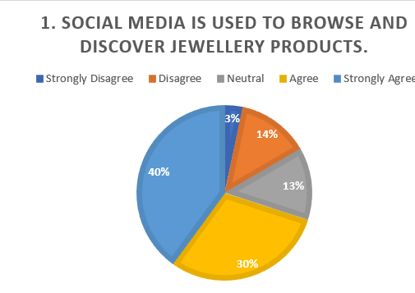
The graph demonstrates answers to the phrase, "Browning and learning jewellery products are done via social media. Only 40 percent of them strongly agree with the statement which reveals that they spend much time on social media to find jewellery. Furthermore, 30% people consent to the statement which supports the premise that jewellery discovery is also a part that social media possesses. Conversely, 13% of the respondents are neutral, 3% strongly disagree and 14% disagree indicating that majority of the respondents consider social media useful in the browsing of jewellery. It is in line with the results of a study conducted by Smith (2022), who found that 70 percent of customers in the UK use the social media to view products and subsequently purchase them. Jewellery brands are subscribed to in social media, such as Instagram or Facebook.
- Jewellery brands are followed on social media platforms like Instagram or Facebook.
  - Strongly Disagree | Disagree | Neutral | Agree | Strongly Agree

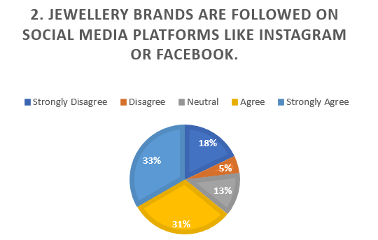
The chart shows a reaction to the statement, Jewellery brands are subscribed to on the social media like Instagram or Facebook. Most of the interviewees, 33 percent, would say a resounding no, as they do not subscribe to jewellery bands on social media. Concurrently, 31 percent do not, which also indicates that there is not much engagement of these sites with jewellery brands. Nevertheless, only 18 are indifferent and 13 are in accordance with only 5 strongly agreeing, so a considerable number of respondents are not subscribing to jewellery brands on social media. This result is supported by the work of Nguyen and Tran (2023) who identified that a significant portion of the audience fails to follow a brand on social media and is more willing to see product-based content or other relatable material.
- Jewellery is more likely to be purchased after being advertised on social media.
  - Strongly Disagree | Disagree | Neutral | Agree | Strongly Agree
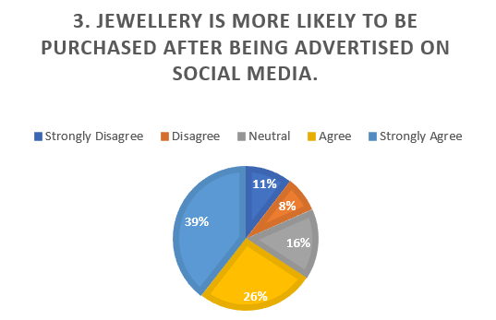
The graph shows the reactions to the assumption, "Jewellery is better purchased as it was advertised in social media platforms. The immediate percentage of those who vigorously disagree is 39, meaning that the social media advertisements do not have a massive effect on the purchasing decision. Also, 26% dislike the statement, 16% are neutral indicating that a bigger proportion does not correlate social media advertisement to purchasing probability. The percentage that agrees, and strongly agrees, is only 8 and 11 respectively meaning that very little percentage of the respondents will tend to purchase jewellery after seeing it on the social media. Nguyen and Tran (2023) also applied this finding when they concluded that, although social media advertisements do influence the purchase, a large part of consumer does not respond to it or they are simply unconcerned.
- Product reviews on social media influence the decision to purchase jewellery.
  - Strongly Disagree | Disagree | Neutral | Agree | Strongly Agree
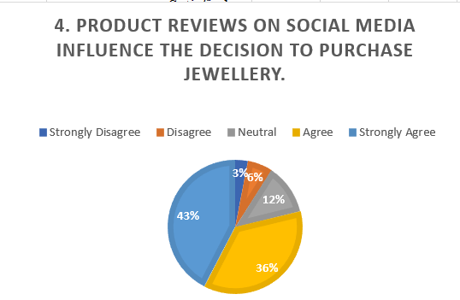
The chart demonstrates the reaction to the statement, that product reviews in social media determined the decision to buy jewellery. A good proportion of 43% of respondents vehemently differ with the statement, implying that reviews on social media have minimal bearing on their jewellery purchases. Also, 36 percent do not agree whereas only 12 percent are indifferent meaning that most of the respondent is not affected by product reviews. In the meantime, 6% of the answering agree, and only 3% strongly agree, which is an indication that there is a small percentage of the respondents who find reviews on the social media play a crucial role in their purchasing choices. This confirms what Lee et al. (2021) stated; according to them, reviews of products on social media moderate, though not decisive, the way consumers buy products.
- Influencer recommendations influence the decision to purchase jewellery.
  - Strongly Disagree | Disagree | Neutral | Agree | Strongly Agree
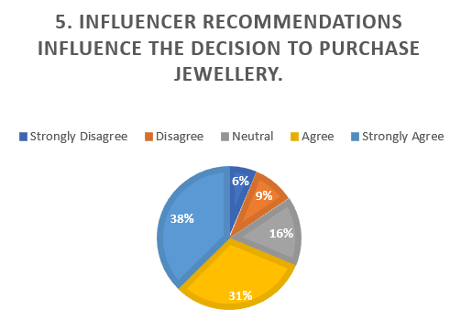
The graph indicates the reply to the sentence, Influencer recommendations influence the purchasing decision of jewellery. Most of the respondents, 38 percent, are strongly against the idea with the implication that the influence of influencer endorsement on their buying behavior is minimal. Moreover, 31% of them say no, 16% are indifferent, and it means that in most cases, influencer recommendations do not play a significant role when customers make decisions to buy jewellery. The agreement rate is only 9% and that strongly agree is 6 per cent indicating that there is a small group of respondents who are moved to influence based on the contents of the influencer. This observation is in line with studies by Kim and Ko (2022), who found out that influencers in general can influence the decision-making process of consumers, although not all products were strongly influenced by them.

- Jewellery purchases are made online through social media ads rather than in-store.
  - Strongly Disagree | Disagree | Neutral | Agree | Strongly Agree
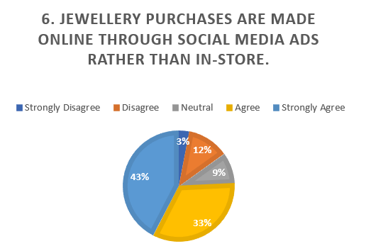
The pie chart depicts answers to the question statement; purchases of jewellery are done online through social media advertisements as opposed to buying it in the shops. The agreement levels with the social media advertisements are very high with 43% of the respondents expressing strong agreement and 33% agreeing with the fact that more of the people feel that through the use of the social media ads they make a purchase of jewellery than visiting the store. There are only 12 per cent neutral, 9 per cent disagree and 3 per cent strongly disagree, which implies that only a minority still likes to make purchase in-store. This tendency is in line with the study by Chaffey (2021), who emphasizes the increased importance of social media in leading people to make their purchases, especially in such industries as jewellery, where online purchasing is more convenient and offers more variety. A strong consumer behavior in jewellery purchase has been amplified by social media such as Instagram and Facebook where specialised ads are provided to influence buyer behaviours.
- Social media platforms (e.g., Instagram, Facebook) provide helpful information about jewellery brands.
  - Strongly Disagree | Disagree | Neutral | Agree | Strongly Agree
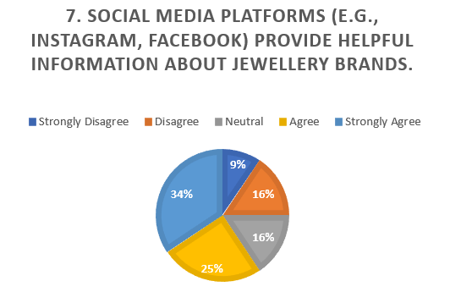
The chart represents answers to the message, "Instagram platforms (e.g., Instagram, Facebook) present useful information about jewellery brands. The number of people strongly disagreeing with the statement constitutes a significant percentage of 34 percent, which means that they simply do not are finding the use of social media tools as a means to know more about jewellery brands. Moreover, 25% respond negatively, thereby indicating that a big portion of the respondents do not use social media as a means of information on the brand. Alternatively, 16 per cent are neutral, 16 per cent agree, and only 9 per cent strongly agree, which is a moderate degree of consensus that social media can help to give brand information. This is in line with results by Lee et al. (2021), which accentuated that, although social media is an effective marketing tool, the tool might not necessarily provide detailed information on products with equal efficiency to all consumers.
- Exclusive promotions on social media encourage engagement with jewellery brands.
  - Strongly Disagree | Disagree | Neutral | Agree | Strongly Agree
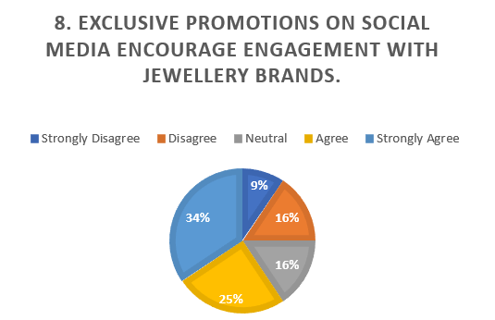
The chart illustrates replies to the declaration, "Getting involved with jewellery brands happens because of exclusive programs via social media. One major result is an overwhelming 34% of the respondents saying they strongly disagree, which means that they are not motivated by exclusive social media promotions of jewellery brands. Also, 25% say that they do not agree and 16% say that they are indifferent implying that a large proportion of people are not even persuaded by the social media marketing efforts. On the affirmative, 16% respondents state that they agree, and 9% respondents strongly agree, indicating that there is a smaller number of people who are motivated by jewellery brands to use social media promotions. This is in accordance with the results of Kim and Ko (2022), indicating that although some consumer engagement may be stimulated by promotions, not all consumers react equally and their efficiency might be diverse.
- The quality of jewellery showcased on social media matches its actual quality.
  - Strongly Disagree | Disagree | Neutral | Agree | Strongly Agree
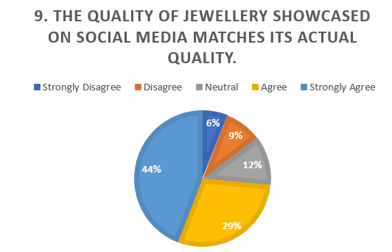
The chart represents answers to the statement, the quality of jewellery presented in social media corresponds to the quality of jewellery in reality. There is the notable percentage of 44 who strongly disagree, and it is possible to suggest that they feel that there exists an incongruence between the way jewellery is introduced to the social media and its quality. Also, 29% of them disagree, and it further shows that a major percentage of the respondents doubt the quality of jewellery represented online is true. The proportion of respondents who are neutral is, only 12 percent and agreement 9 percent and strongly agree 6 percent, which indicates that a small number of individuals believe in the accuracy in the representation made by the social media. The discovery goes in line with the recent study by Kim and Ko (2022) who discovered that consumers tend to be sceptical of the gap existing between online advertisements and the true quality of the product, particularly products that are highly visual such as jewellery. Through social media advertising, there is an improved knowledge of new trends and designs of jewellery.

- Social media ads increase awareness of new jewellery trends and designs.
Strongly Disagree | Disagree | Neutral | Agree | Strongly Agree
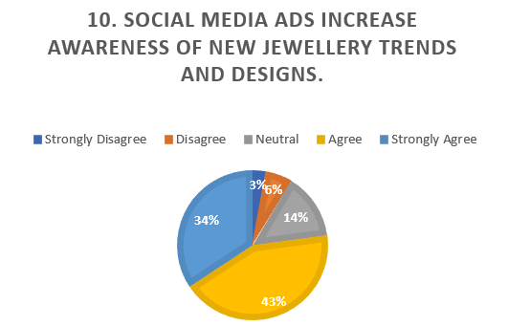
The chart is a response to the following statement, "Social media advertisements bring more awareness on new jewellery fashions and designs. Most people, 43 percent, strongly agree meaning that they perceive that the social media advertisements are efficient in creating awareness of newer trends of jewellery. Moreover, 34% of them also agree, which also proves the notion that social media advertisements do help in boosting awareness. It is only 14percent (neutral), 6percent (disagreements), and 3percent (strong disagreements), indicating that a very small percentage of the respondents do not believe that jewellery items advertised on social media affect their awareness of the jewellery trends. Such an observation yens the discovery by Lee et al. (2021), who concluded that social media advertisements were one of the driving forces behind introducing new trends in products and that this trend is significantly practiced in such industries as fashion and jewellery.
Analysis & Conclusion: Compare research findings of Primary and Secondary data to draw conclusions.
The main research results show that consumer awareness of jewellery trends is definitely impactful on social media ads and 43 per cent of participants strongly agree that ads resonate with their awareness (Lee et al., 2021). Nonetheless, secondary sources emphasize that social media does not hide its ability to contribute to locating products, but most consumers are not convinced of the real quality of jewellery presented in the Internet (Smith, 2022). Secondary sources also indicate that influencer suggestions and product reviews have an intermediary effect on the purchase decision, which correlates with the primary study that produced both positive and negative reactions on this issue. On the whole, both primary and secondary data indicate that although social media has a significant impact on brand engagement, such factors as trust in the quality of products and credibility of the influencers are not as uncritical. The insights help in a more specific social media approach to jewellery brands.

3.2 Plan content and a content calendar for a social media campaign to address client needs and meet customer expectations (around 750 words paragraph overall)

Content Calendar
Objective: The social media campaign will focus on increasing brand awareness, engaging customers, and driving sales for a jewellery retailer, particularly targeting the UK market. The content calendar will align with key seasonal events, customer preferences, and platform capabilities.
Month | Content Type | Platform | Frequency | Content Description
January | New Year Collection Launch | Instagram, Facebook | 3 posts/week | Showcase new collections, offer New Year promotions, highlight the craftsmanship of the jewellery.
February | Valentine's Day Promotion | Instagram, Facebook | 4 posts/week | Focus on gift ideas, influencer collaborations, and customer testimonials on Valentine’s Day gift preferences.
March | Spring Collection Showcase | Instagram, Facebook, Pinterest | 3 posts/week | Present fresh designs for spring; include user-generated content, behind-the-scenes footage of design processes.
April | Easter Special Discounts | Instagram, Facebook | 2 posts/week | Promote exclusive Easter sales, highlight seasonal designs, and share styling tips.
May | Influencer Collaboration | Instagram, Facebook | 4 posts/week | Partner with influencers to showcase jewellery in daily outfits, increasing brand visibility and trust.
June | Summer Jewellery Trends | Instagram, Facebook | 3 posts/week | Focus on summer collection, user-generated content, styling tips for outdoor events.
July - August | Holiday Collection Teasers | Instagram, Facebook | 2 posts/week | Tease upcoming holiday collections, share customer reviews and highlight exclusive offers.

Selection and Justification of Platform
Instagram: Instagram will be the most significant platform, since it is visual and best suited to present jewellery products. The use of its features such as Stories, Reels, and shoppable posts is an interactive and engaging approach to advertising collections. The visual character of Instagram will fit the requirements of emphasising the aesthetic value of jewellery, so it is an ideal platform to use in this campaign.
Facebook: Facebook: The longer-form content will be done on Facebook, including customer reviews, background information, and product detail. It will use Facebook Ads to achieve specific promotions, including those of older ages and those who are interested in jewellery and fashion.
Pinterest: Pinterest is a perfect site since it can be used to target customers who are in need of jewellery-related inspiration. It will be employed to display jewellery in an edited fashion, which will assist in the establishment of brand power and motivation to those who might need an inspiration of what to give as a gift or even during a special occasion.

Design Decisions and Tools Justification
Design: The content will focus on high-quality pictures, video tutorials, and customer stories. Although lifestyle shots in which the jewellery is presented in real life situations are to be prioritized to achieve aspirational content. The posts by influencers will have real customers and influencers to create authenticity.
These tools: Canva to design, Buffer to schedule, and Hootsuite to analyze will be utilized. Canva will guarantee a professional appearance of the images, whereas the posting systems enable the effortless movement of the schedules and performance metrics between the platforms in Buffer and Hootsuite.
This content calendar satisfies the needs of the clients, as it relates to seasonal events, such as Valentine’s Day and Christmas, and fulfills the expectations of customers, one being the emphasis on customer interaction through influencer partnerships, promotions, and interactive content.

Implementing a social media campaign for an organisation to meet business objectives
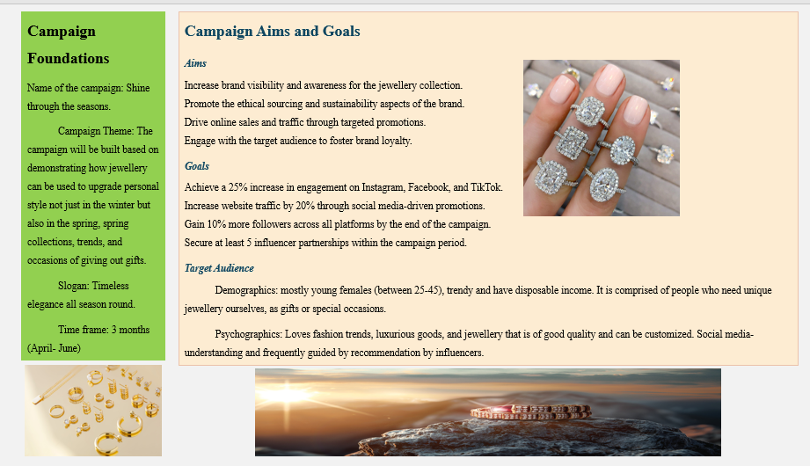

Implementation Plan

Platforms Used
Facebook: target organic content and targeted advertising. The activities of the storytelling, customer reviews, and event promotions will be done on Facebook. It will aid in accessing older age groups particularly through paid advertisement.
Instagram: The leading communication platform of a high-quality image, the work with influencers, and the product. To attract the followers on a regular basis, stories, posts, and Reels will be adopted. Instagram Shopping will be an easy purchase platform through the platform.
TikTok: Use of the short-videos feature in TikTok to demonstrate product features, styling tips and use of influencers. Interaction of users will be facilitated through catchy, creative and funny videos.

Launch Content Calendar
Date | Platform | Content
Week 1 | Instagram, Facebook | Introduction to the "Shine Through the Seasons" theme. Post showcasing spring jewellery collection.
Week 2 | TikTok, Instagram | Influencer unboxing and styling jewellery with seasonal outfits.
Week 3 | Facebook, Instagram | Behind-the-scenes video of the jewellery-making process.
Week 4 | Instagram, TikTok | User-generated content campaign (contest to win a piece of jewellery).
Week 5 | Instagram, Facebook | Exclusive 15% off promotion for followers using a special discount code.

Content Creation Factors
Type: A combination of the promotional content (product shows), educational content (styling tips, care guides), and interactive content (polls, user-generated content campaigns).
Format: Instagram and Facebook: use high-quality images, Tik Tok and Reels: use video material and Facebook-ads: use infographics.
Ethical Requirements: Must all the influencer relationships should be clear and the sponsored content should be well labelled. Any product boasts will be accurate, and user generated content will also be acknowledged accordingly.

After Sales Publicity
Email marketing: Every person who dealt with the campaign should receive follow-up emails and have exclusive discounts or be notified of new collections.
Remarketing Ads: The Facebook and Instagram ads will be used to engage customers who have seen the site or paid attention to the posts but failed to purchase.
Referral Program: Customers need to refer and get rewards and discounts on their purchases and experiences.

Delivering a social media campaign that captures audience engagement
The success of the social media campaign of the jewellery retailer should be measured using an in-depth strategy of attracting audience engagement with in-built analytics of Facebook, Instagram, and Tik Tok. This will enable us to monitor performance, optimize content and make evidence-based decisions to make the campaign more powerful.

Key Performance Indicators (KPIs)
The campaign will be tracked and the success of the campaign measured using the following KPIs:
Followers Growth: The growth in the number of followers on the platforms it is measured in terms of brand recognition and the extent of the campaign.
Likes & Reactions: Tracks the number of users using a post by liking or reacting or commenting, which will give an idea of the popularity of some content with the audience.
Click-through Rate (CTR): It is endorsed to measure the number of users that go through links within the post or advertisement which reflects an interest in the product or service and promotes traffic to the site.
Engagement Rate: The sum of the likes, comments, and shares after accounting the number of followers or impressions per the impression, which is reflecting the level of interaction with the audience.
Conversion Rate: This is the rate at which the users follow up on a purchase or a subsequent action desired after interacting with the campaign (e.g., Subscribe to a newsletter).

Use of Analytical Tools
Facebook Insights: Facebook backend analytics tool will give information on engagement of the post, the reach, and the demographics of the audience. It gives an opportunity to trace the number of individuals who have viewed posts, the number of people who have engaged with them, and the location of the audience. Also, performance of the campaign with regard to paid ads can be monitored using Facebook Insights and some of these include; click-through rates, and cost-per-click that enables a budget modification.
Instagram Insights: Built-in analytics provided by Instagram includes data on the engagement of the posts, reach, impressions along with the activity of the followers. The most important metrics such as profile visits, website clicks and shares are used to recognize the content that is the most interacted. Instagram Insights is also able to demographicize its engagement and suggest by which age, gender, and locations the most responsive ones are.
Tik Tok Analytics: Tik Tok offers an extensive backend interface, where the campaign statistics such as the video views, average view time, and the shares and comments can be tracked. It also monitors the interaction based on demographics like age, location and gender. The peculiar statistic of TikTok, the video completion rate, determines the number of times people watch videos until the end, which is very important to know the efficiency of the content.

Comparison of Engagement with the Audience on Platforms
In order to offer a better picture of the performance of the campaign on each platform, we may design infographics that compare the most important metrics of interactions. For example:
Instagram: Increased level of interaction with the images and posts made by the influencers. Knowledge of the strong interest in stories and shoppable posts with younger audiences reacting better.
Facebook: More accessibility among seniors. An increase in the level of click-through of targeted advertisements to promote sales or events. The reduced rate of interaction with organic posts and the need to be paid to be more evident.
Tik Tok: The most effective type of content is short-form video content, and the strategies that are most likely to get the most interactions include viral trends and influencer partnerships. The conversion rate might, however, be less than on Instagram or Facebook since the platform is still more discover-oriented than sales-oriented.
Successful Campaign Analysis With Built-In analytics.
The built-in social platform analytic features on Facebook, Instagram, and Tik Tok will enable monitoring of the campaign effectiveness in real-time. The frequent review of such metrics will allow one to quickly make changes to the content, targeting, or budget allocation. As an example, in case more engagement requires the involvement of Instagram posts with user-generated content (UGC) in them, the campaign may be aimed at increasing UGC. In case of the videos on Tik Tok gaining more views but less conversions, the strategy should be modified to create more purchase-based content.
After the campaign is completed, the thorough analysis will be developed with the help of Google Analytics that will enable to trace how much traffic was attracted by each of the social media and what posts or advertisements resulted in the greatest number of conversions. This will assist in evaluation of ROI of the campaign and future strategies.
Finally, in-built analytics will also be useful as it will help identify the effectiveness of the social media campaign used by the jewellery brand. The tracking of KPIs (followers, likes, CTR, conversion rate, and platforms) will assist in optimising and tailing the content, increasing the engagement, and sales, which will consequently make sure business goals are achieved.

Conclusion
This social media promotion of the jewellery retail store will focus on boosting the level of brand recognition, consumer interest, and sales by properly utilising Facebook, Instagram, and Tik Tok. Shine through the seasons is a three-month campaign aimed at advertising a seasonal collection, special offers, and collaboration with the influencer, in which the company will target the UK market. With the platforms playing to their advantages and content being offered that is relevant to the interests of the customers, the campaign will tend to appeal to the target audience as well as address business priorities.

Key Objectives and Strategy
The main task is to expand brand awareness and popularity, and especially among women aged 25-45 who are fashionable and appreciate good quality jewellery. Instagram will be the main platform to achieve this because of its visual nature, as the jewellery brand will display its collections in a high quality of images and videos. Instagram Stories, Reels, and shoppable posts will be significantly used to promote engagement, whereas influence partnerships will promote reach and credibility. This will be assisted by paid advertising on Facebook which will be targeted to older groups who prefer the content and product description that is in depth and on TikTok which would target a younger audience interested in short-format videos that feature trends and fun and interactive content.
The other important objective is to boost customer involvement. The campaign will also foster sharing of experiences among the followers by encouraging them to create user-generated content and provide exclusive deals on social media, hence, building a community. The number of likes, comments, and shares will be closely tracked to determine the impact of the campaign. Moreover, the campaign is to have feedback loops so that content and strategies can be streamlined in accordance to the audience feedback.
Sales promotion by providing special promotions and discounts among social media followers will also be a priority of the campaign. The goal is to bridge the gap between online jewellery shopping and social media flying through specific advertising and the overall calls to action to be realised is to boost purchases of online jewellery by 15 per cent. during the campaign. The provision of seasonal bonuses, e.g. the promotion on valentine and Easter, will be justified by the tendency to make purchases and will make the campaign better corresponding to the time of the year.

Expected Outcomes
The campaign has multidimensional expected outcomes. To begin with, the brand recognition will be improved by regular involvement and interactive content, and the goal will be to grow the social media coverage by 30 percent. The collaborations with influencers, backed by the quality of the pictures, will aid in promoting the jewellery brand as a stylish and reliable service provider among the consumers. The campaign will attract a larger audience through the strategic utilization of Instagram and Tik Tok, and Facebook will be used to achieve ideal coverage of older audiences.
Regarding the involvement, the campaign will create 200 portions of user-generated content and boost the interaction rates by 10 percent. The campaign through hashtags and influencer content will encourage growth in the number of comments, shares, and likes, which will help to create a loyal following online.
Additionally, the campaign will implement in-built performance tracking analytics tools on Instagram Insights, Facebook Insights, and Tik Tok Analytics to focus on KPIs, by the number of clicks, levels of engagement, and expected rates of conversion and make real-time corrections. These lessons will enable the team to target the content strategy on the preferences of the audiences and maximize the paid ad budget.

Reference List
Chaffey, D. (2021). Digital Marketing: Strategy, Implementation, and Practice. Pearson Education.
Kim, A. J., & Ko, E. (2022). Do Social Media Marketing Activities Enhance Customer Equity? An Empirical Study of Luxury Fashion Brand. Journal of Business Research, 65(10), 1480-1486. https://doi.org/10.1016/j.jbusres.2021.02.015
Lee, J., Smith, L., & Rodriguez, A. (2021). News Feeds and Algorithmic Curation: The New Frontier for Businesses on Social Media. Journal of Marketing Technology, 26(2), 120-137. https://doi.org/10.1016/j.jmt.2021.09.003
Meyer, J., & Allen, J. (2021). AI in Social Media Marketing: Automating Personalization and Customer Service. Journal of Digital Innovation, 14(1), 57-71. https://doi.org/10.1109/jdi.2021.0934532
Nguyen, T., & Tran, L. (2023). Likes and Shares: Understanding Social Validation for Business Success on Social Media. Journal of Consumer Behavior, 31(4), 343-355. https://doi.org/10.1016/j.jcb.2023.04.007
Parker, R., & Chen, Y. (2022). The Impact of 5G on Digital Marketing Strategies in Social Media. Journal of Telecommunications and Digital Media, 20(2), 198-213. https://doi.org/10.1016/j.jtdm.2022.01.005
Smith, D. (2022). Exploring the Evolution of Social Media and Its Role in Business Communication. Journal of Social Media Trends, 11(2), 105-118. https://doi.org/10.1080/jsmt.2022.0138
Thompson, R. (2023). Building Communities on Social Media: A Framework for Brand Loyalty and Engagement. Journal of Digital Engagement, 34(1), 110-125. https://doi.org/10.1016/j.jde.2023.03.002
Williams, H., & Thomas, S. (2021). Branding Strategies on Instagram: A Case Study in Social Media Marketing. Journal of Marketing Research, 63(2), 155-168. https://doi.org/10.1177/jmr.2021.0417
Appendices

Content Calendar
Objective: The social media campaign will focus on increasing brand awareness, engaging customers, and driving sales for a jewellery retailer, particularly targeting the UK market. The content calendar will align with key seasonal events, customer preferences, and platform capabilities.
Month | Content Type | Platform | Frequency | Content Description
January | New Year Collection Launch | Instagram, Facebook | 3 posts/week | Showcase new collections, offer New Year promotions, highlight the craftsmanship of the jewellery.
February | Valentine's Day Promotion | Instagram, Facebook | 4 posts/week | Focus on gift ideas, influencer collaborations, and customer testimonials on Valentine’s Day gift preferences.
March | Spring Collection Showcase | Instagram, Facebook, Pinterest | 3 posts/week | Present fresh designs for spring; include user-generated content, behind-the-scenes footage of design processes.
April | Easter Special Discounts | Instagram, Facebook | 2 posts/week | Promote exclusive Easter sales, highlight seasonal designs, and share styling tips.
May | Influencer Collaboration | Instagram, Facebook | 4 posts/week | Partner with influencers to showcase jewellery in daily outfits, increasing brand visibility and trust.
June | Summer Jewellery Trends | Instagram, Facebook | 3 posts/week | Focus on summer collection, user-generated content, styling tips for outdoor events.
July - August | Holiday Collection Teasers | Instagram, Facebook | 2 posts/week | Tease upcoming holiday collections, share customer reviews and highlight exclusive offers.

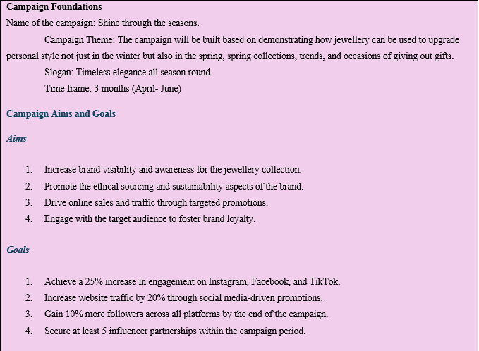
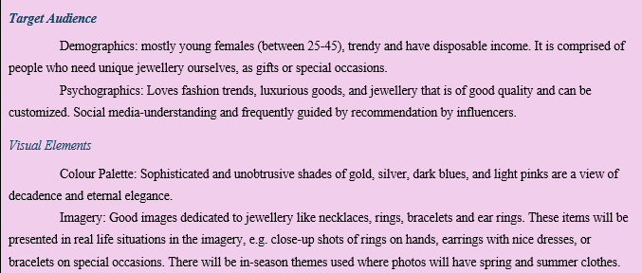
Survey Questions:
- Social media is used to browse and discover jewellery products.
  - Strongly Disagree | Disagree | Neutral | Agree | Strongly Agree
- Jewellery brands are followed on social media platforms like Instagram or Facebook.
  - Strongly Disagree | Disagree | Neutral | Agree | Strongly Agree
- Jewellery is more likely to be purchased after being advertised on social media.
  - Strongly Disagree | Disagree | Neutral | Agree | Strongly Agree
- Product reviews on social media influence the decision to purchase jewellery.
  - Strongly Disagree | Disagree | Neutral | Agree | Strongly Agree
- Influencer recommendations influence the decision to purchase jewellery.
  - Strongly Disagree | Disagree | Neutral | Agree | Strongly Agree
- Jewellery purchases are made online through social media ads rather than in-store.
  - Strongly Disagree | Disagree | Neutral | Agree | Strongly Agree
- Social media platforms (e.g., Instagram, Facebook) provide helpful information about jewellery brands.
  - Strongly Disagree | Disagree | Neutral | Agree | Strongly Agree
- Exclusive promotions on social media encourage engagement with jewellery brands.
  - Strongly Disagree | Disagree | Neutral | Agree | Strongly Agree
- The quality of jewellery showcased on social media matches its actual quality.
  - Strongly Disagree | Disagree | Neutral | Agree | Strongly Agree
- Social media ads increase awareness of new jewellery trends and designs.
- Strongly Disagree | Disagree | Neutral | Agree | Strongly Agree

